Title Page

Sunday Lawn -Implementation

Author: Natalia Sanchez Castillo

Date: January 17th, 2023

Copyright Information: Canadian Fair use for educational purposes

Version 0.1(draft) October 10, 2005

By Mark Baldwin

Baldwin Consulting

http://baldwinconsulting.org

The Game Design Document (GDD) it the blueprint from which a computer or video game is to be built. As such, every single detail necessary to build the game must be addressed in the document (or support documents). If it's not in the document, then it probably won't be in the game.

Below you will find an outline for a generic Game Design Document. The problem is that no generic GDD will be able to address all the various genres for which a game may be created. For example, consider the games PacMan, SimCity and Doom. All three games required detailed design documents, but if you think about it, those documents would be entirely different! As such, when using the outline below you will find sections that will be totally meaningless to your game. But also, there will be sections that your GDD requires to describe the game. Just because it's not in my outline, it doesn't mean that it doesn't belong.

The GDD is a reference document. Members of the development team will constantly be using the document to find specific information for their specific needs. Consider the size such a document may grow to in order to document every piece of the game. We don't want the GDD to cause information overload and then become a prop under somebody's wobbly desk. As such it is important that you organize and format the document to make it easy to use. Also note that some of these sections might not appear in the GDD itself but instead would appear in supplemental documents such as an Art Bible or Test Plan. This helps make the overall document more manageable and readable.

One last comment, a game design document is meant to be a living document. Just as when the artist changes the design of his painting every time he takes his brush to the canvas, a computer or video game evolves as code and art are created. The GDD then is the communication tool from which all the members of the team can follow that evolution.

**Document Revision history:**

|  |  |  |  |
| --- | --- | --- | --- |
| Version | Date | Author(s) | Changes |
| 0.2 | January 16, 2013 | Emile Cormier |  |
| 0.3 | January 05, 2016 | David Burchill |  |
| 0.4 | January 17, 2023 | Natalia Sanchez | First draft |
| 0.5 | April 11, 2023 | Natalia Sanchez | Final |

*(Use word's "update table of contents" to generate / regenerate a table of contents. )*

Table of Contents

1. Section I - Game Overview 7

1.1. Game Concept 7

1.2. Design History 7

1.3. Feature Set 7

1.4. Genre 7

1.5. Target Audience 7

1.6. Game Flow Summary 7

1.7. Look and Feel 7

1.8. Project Scope 8

1.8.1. Number of locations 8

1.8.2. Number of levels 8

1.8.3. Number of NPC's 11

2. Section II - Gameplay and Mechanics 11

2.1. Gameplay 11

2.1.1. Game Progression 12

2.1.2. Mission/challenge Structure 12

2.1.3. Puzzle Structure 12

2.1.4. Objectives – What are the objectives of the game? 12

2.1.5. Play Flow – How does the game flow for the game player 12

2.2. Mechanics 12

2.2.1. Physics 12

2.2.2. Movement 13

2.2.3. Objects 13

2.2.4. Actions 13

2.2.5. Combat 13

2.2.6. Economy 13

2.3. Screen Flow 14

2.3.1. Screen Flow Chart 14

2.3.2. Screen Descriptions 15

2.4. Game Options 15

2.5. Replaying and Saving 15

3. Section III – Story, Setting and Character 15

3.1. Story and Narrative 15

3.1.1. Back story 15

3.1.2. Plot Elements 16

3.1.3. Game Progression 16

3.1.4. License Considerations 16

3.2. Characters 16

3.2.1. Character #1 16

4. Section IV – Levels 17

4.1. Level #1 17

4.1.1. Synopsis 17

4.1.2. Objectives 17

4.1.3. Physical Description 17

4.1.4. Map 17

4.1.5. Critical Path 18

4.1.6. Encounters 18

4.1.7. Level Walkthrough 18

4.1.8. Closing Material 18

5. Section V - Interface 19

5.1. Visual System 19

5.1.1. HUD - What controls 19

5.1.2. Menus 19

5.1.3. Rendering System 19

5.1.4. Camera 19

5.1.5. Lighting Models 19

5.2. Control System 19

5.3. Audio 19

5.4. Music 20

5.5. Sound Effects 20

5.6. Help System 20

6. Section VI - Artificial Intelligence 20

6.1. Enemy AI 20

6.2. Friendly Characters 20

6.3. Support AI 20

6.3.1. Player and Collision Detection 20

7. Section VII – Technical 20

7.1. Target Hardware and operating system 20

7.2. Supported game controllers and peripherals 20

8. Section VIII – Game Art 21

8.1. Characters 21

8.2. Environments 21

8.3. Menus 22

# Section I - Game Overview

## Game Concept

Sunday lawn is a game developed in summer in a small town in Italy. Since it is summer, the grass on the houses in this neighbourhood has not stopped growing. The main character, Pablo, aims to keep his neighbours' grass short with the highest number of points. This is a top-down, side-scroller and single-player game.

In the game, Pablo will have to face different scenarios. Houses with extensive gardens and in them various enemies which you must avoid in order not to hurt yourself or damage your lawn tractor. The enemies that Pablo can find are dogs or porcupines. The game has different levels; To play the following levels, the player must unlock them. To do this, you must complete the previous levels successfully.

## Design History

## Feature Set

Sunday lawn is a casual game. The game is located in a small town in Italy. The aesthetics of the game is typo pixel art. The days are sunny, and the houses are colourful. In the game, the player will have to cut all the grass of the assigned home. The user will earn points for every square meter cut.

The main character of the game is Pablo. Pablo is a young adult who wants to earn extra money in the summer. For this reason, he mows the grass in his neighbourhood. In the video game, we find two enemies that Pablo will have to face. The first is the dogs that guard the house. They can leave traps (poop) that the player must avoid. The second enemy is the porcupines which can injure the player.

## Genre

Sunday lawn is a casual game.

## Target Audience

Sunday Lawn is a game for all ages.

## Game Flow Summary

The game is in the third person, and the screen moves up and down and side to side.

The main character will be controlled with the up, down, left and right arrows. Likewise, it can be moved with the keys W (up), A (left), S (down), and D (right). The enter key will be used to select within the menus. The P key will pause the game, and the Q will exit the level.

## Look and Feel

Sunday Lawn is a 2D game. It is similar to pixel art. Overall, the game is colourful and happy. It is set in the summer season and a suburban zone. It has country houses and extensive gardens. It plays with the colours and sounds.

## Project Scope

A summary of the scope of the game.

### Number of locations

In the game, there are 5 different locations. All of them are suburban houses with various gardens.

### Number of levels

Each location would be at a different level. Hence, the game will have 5 levels

LEVEL 1

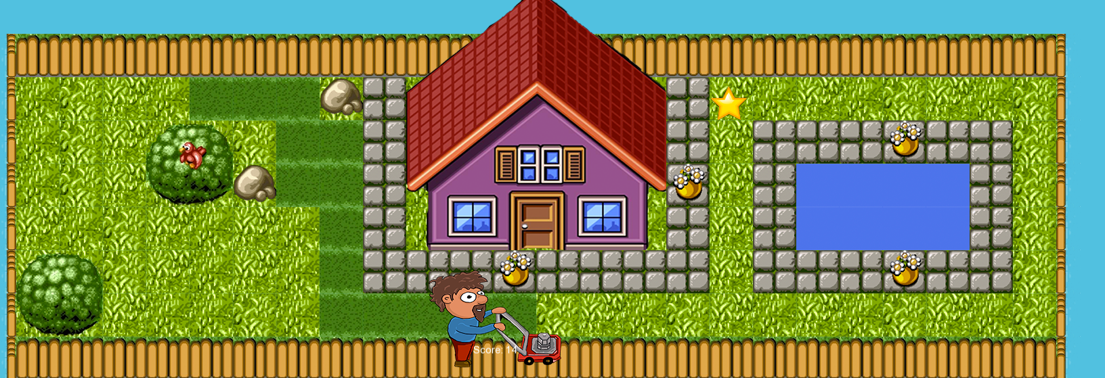

LEVEL 2

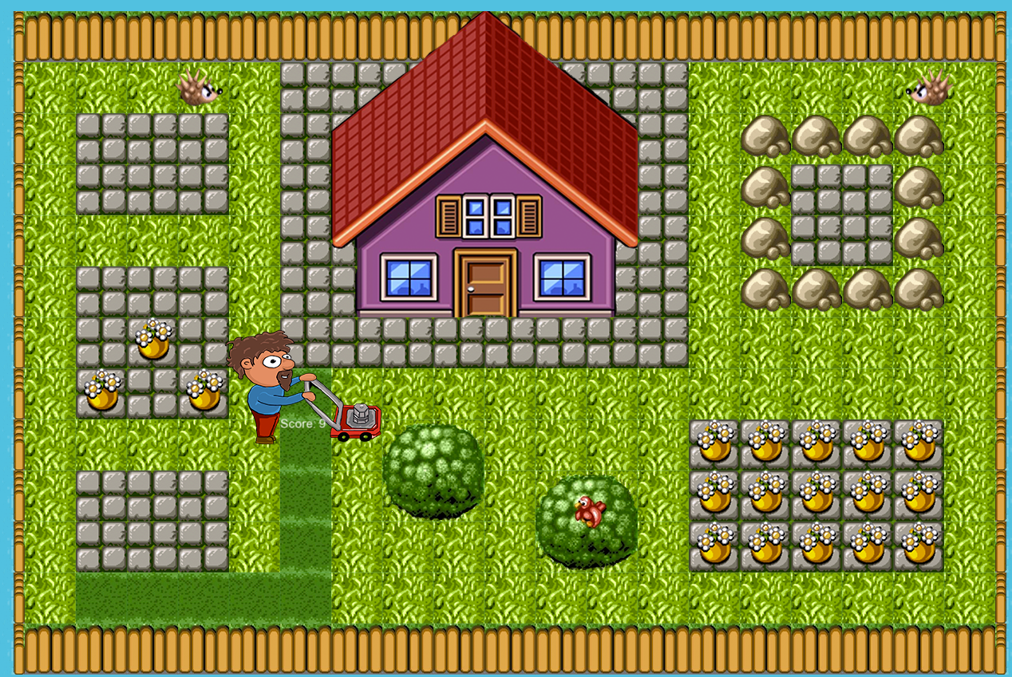

LEVEL 3

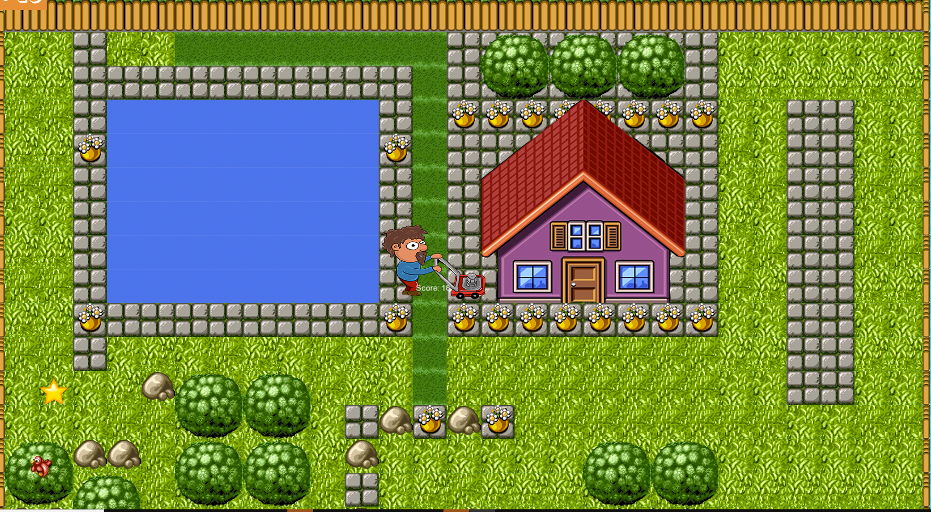

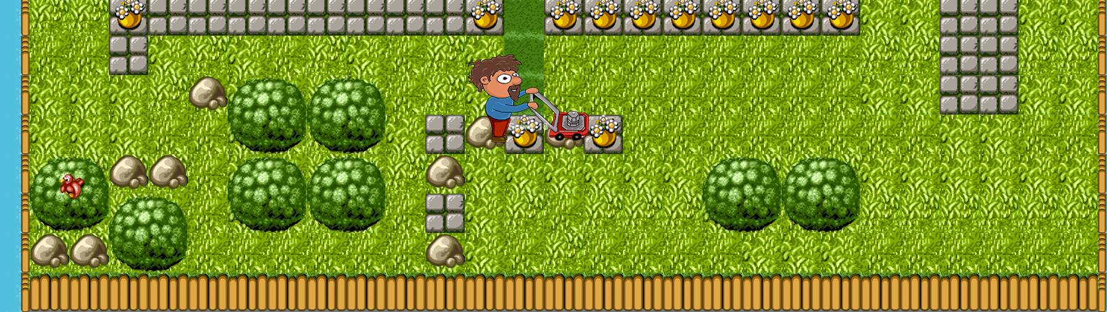

LEVEL 4

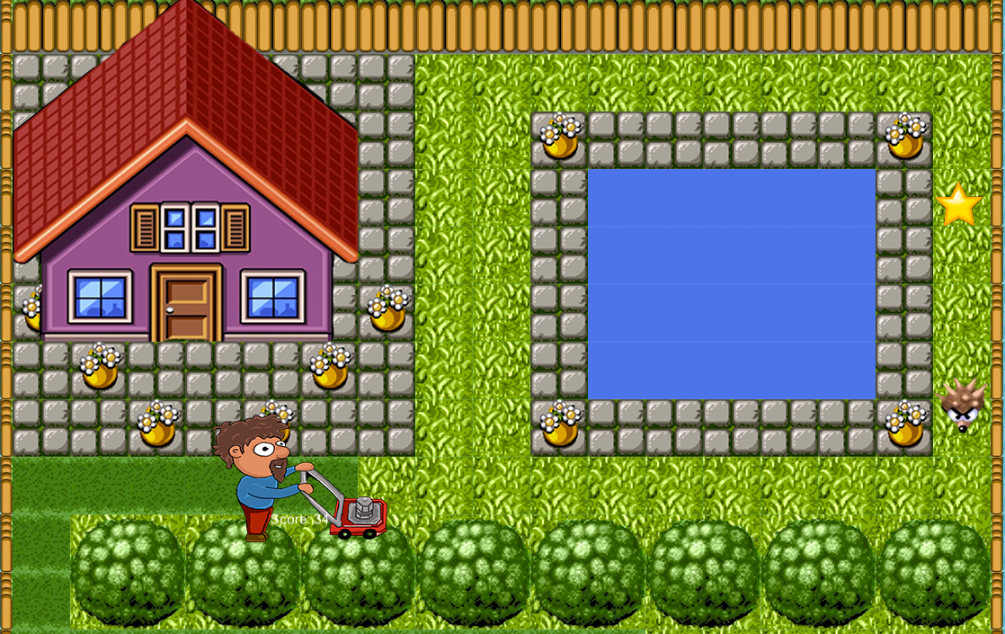

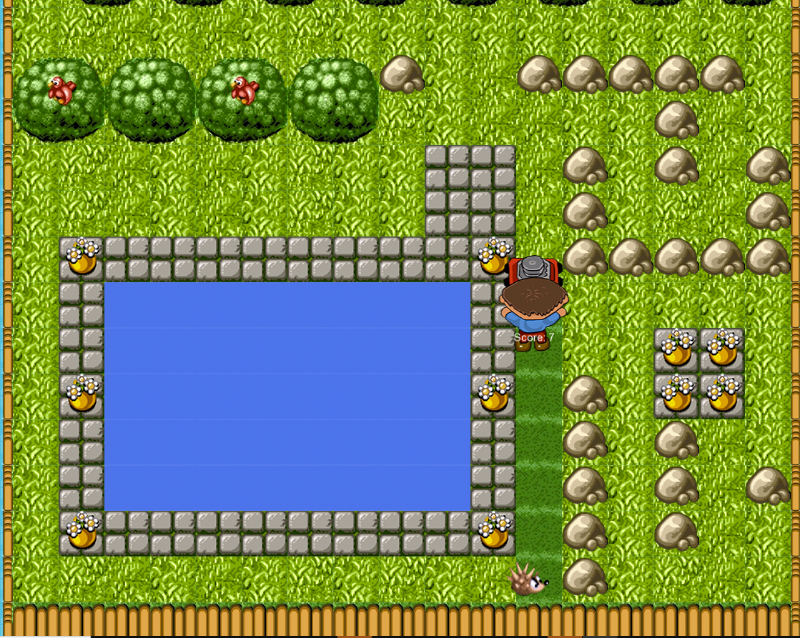

LEVEL 5

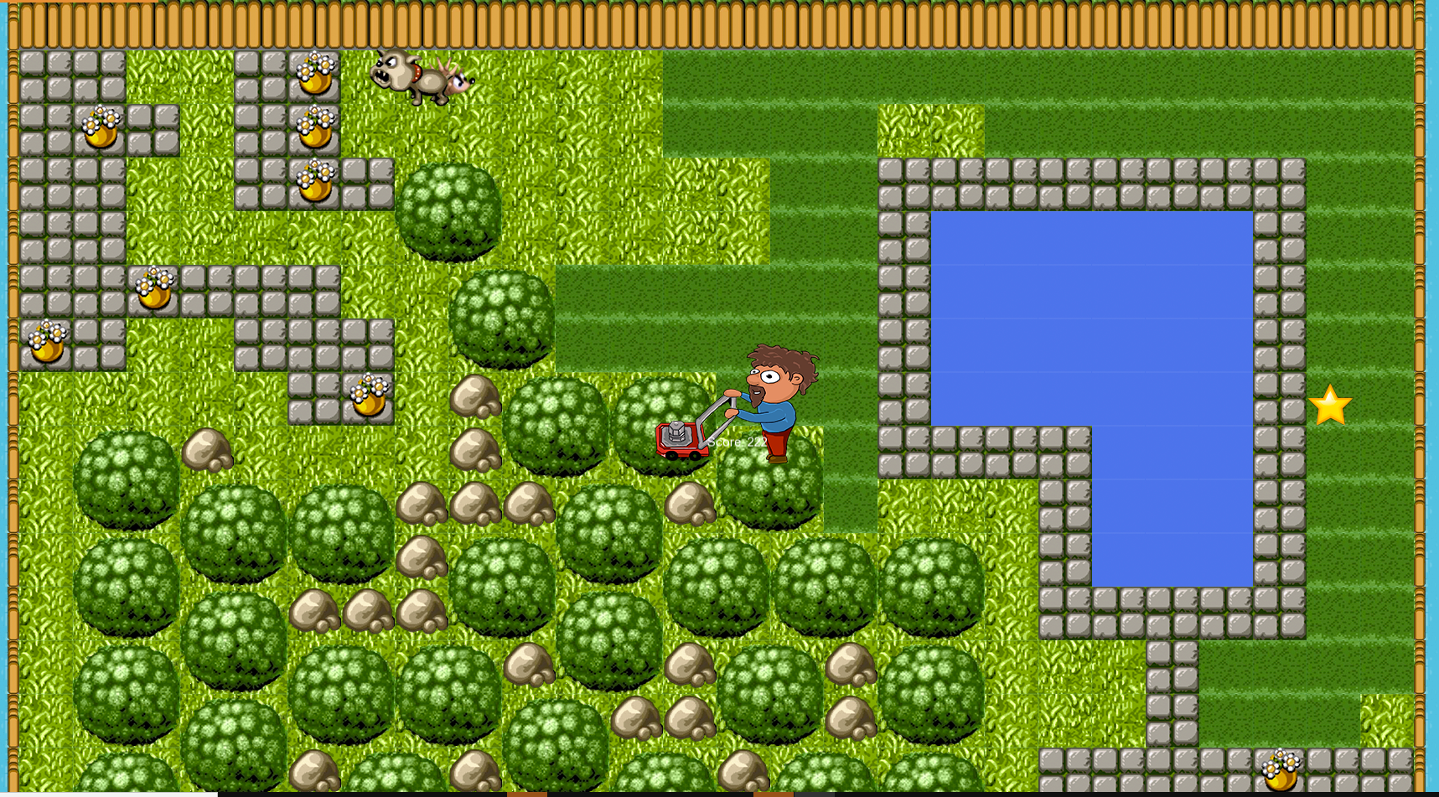

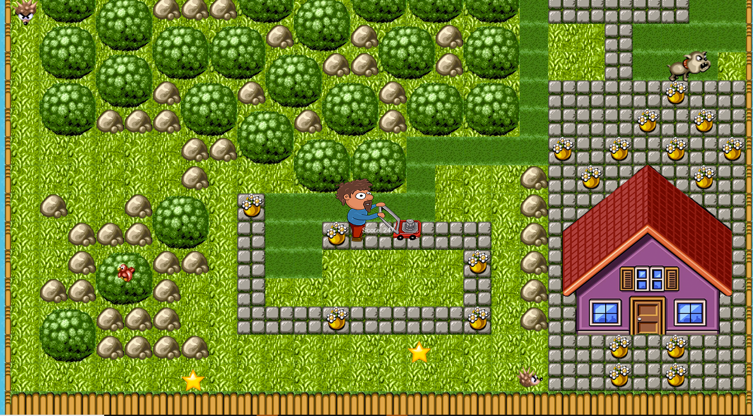

### Number of NPC's

There are 3 types of non-player characters:

* Dogs
* Porcupines

# Section II - Gameplay and Mechanics

## Gameplay

### Game Progression

The game has 5 different levels. At the beginning of the game, only the first level is unlocked. As the player completes each level, the following levels are unlocked and accessible to the player.

### Mission/challenge Structure

The game's ultimate goal is to keep the main character's neighbourhood spotless. For this, the player must go through each house and mow the grass. The player will find a different house or map at each level, meaning the obstacles will differ. Each map is made up of stones, trees, fences and/or pools.

The player will receive stars at each level depending on his performance (the score the user obtains). The more square meters of grass cut, the more points you will get. When completing each level and receiving points for performance, the player will also receive stars depending on the score obtained. Each level will be unlocked when the player completes the previous level.

### Puzzle Structure

All levels of the game are located in the garden of a house. The map is a maze type, in which the player must walk and find the best way to cut all the grass and get the most points. On the map you can find houses, tiles, trees and rocks that will be arranged in different locations.

### Objectives – What are the objectives of the game?

* The game aims to keep his neighbours' grass short with the highest number of points.
* Obtain as much points as possible

### Play Flow – How does the game flow for the game player

The first screen the player sees is the main menu. In it you can find 2 buttons. One to go to the level menu and the other to the game options.

In the level menu, the player can see all the levels listed. The player must choose the first level. When you enter the next screen, the game will start when the player presses the first key. There you can move with the arrow keys or with the keys A, S, D, W.

Within the game, the user will be able to pause the game, quit or restart it.

## Mechanics

All objects on the map can collide with the player.

### Physics

As mentioned in the previous section, all objects can collide with the player. Enemies (dogs and porcupines) do not collide with each other. At the same time, the enemies collide with the objects of the maze, trees, rocks, and tiles.

### Movement

#### General Movement

The player can move in four directions:

Up, down, left, and right, the player cannot pass through the objects on the map (maze).

#### Other Movement

The view will move according to the player since some maps are bigger than the view. The view can be scrolled from left to right and from top to bottom.

### Objects

#### Picking Up Objects

The player can pick up the following objects only by passing over them:

* Speed booster: will increase the speed of the character

#### Moving Objects

* Mower: It moves with the main character.

### Actions

#### Switches and Buttons

In the game there are buttons which allow you to open and close sections of the map. These buttons are activated when the player lands on them.

#### Picking Up, Carrying and Dropping

The player can pick up objects only by passing over them

#### Talking

Pablo, the main character, does not talk.

#### Reading

### Combat

There is no combat in the game.

### Economy

The are no resources to manage economy.

## Screen Flow

### Screen Flow Chart

**Main menu screen**

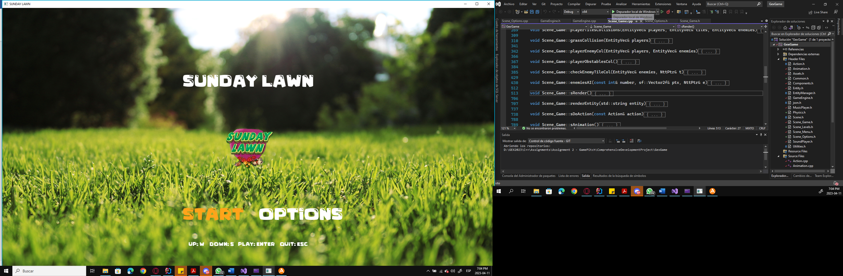

**Game Screen**



**Game Paused Screen**

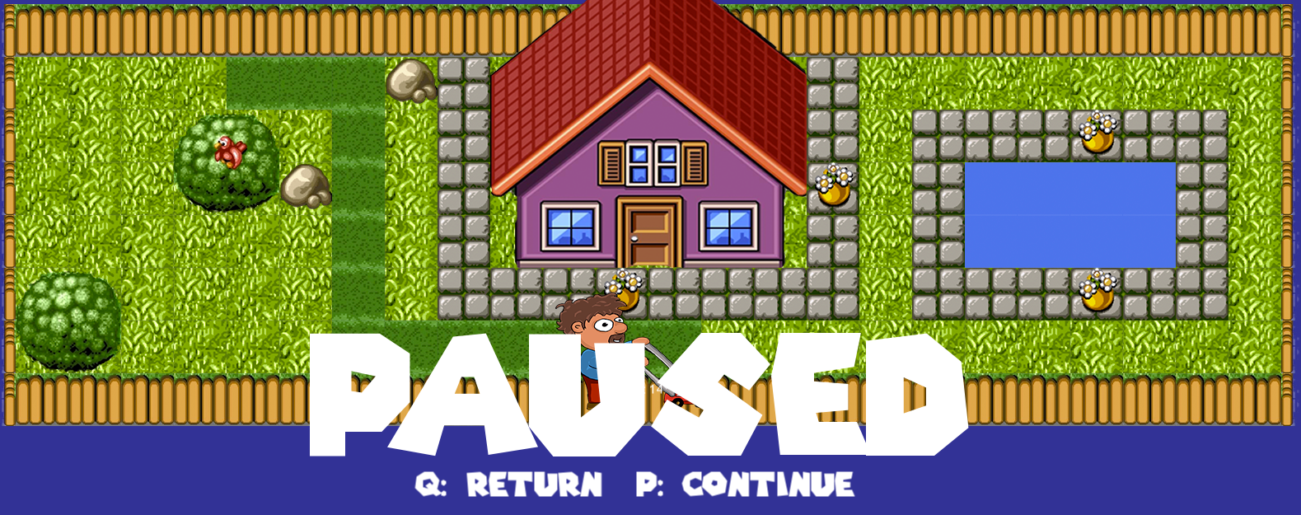

**Win level screen**

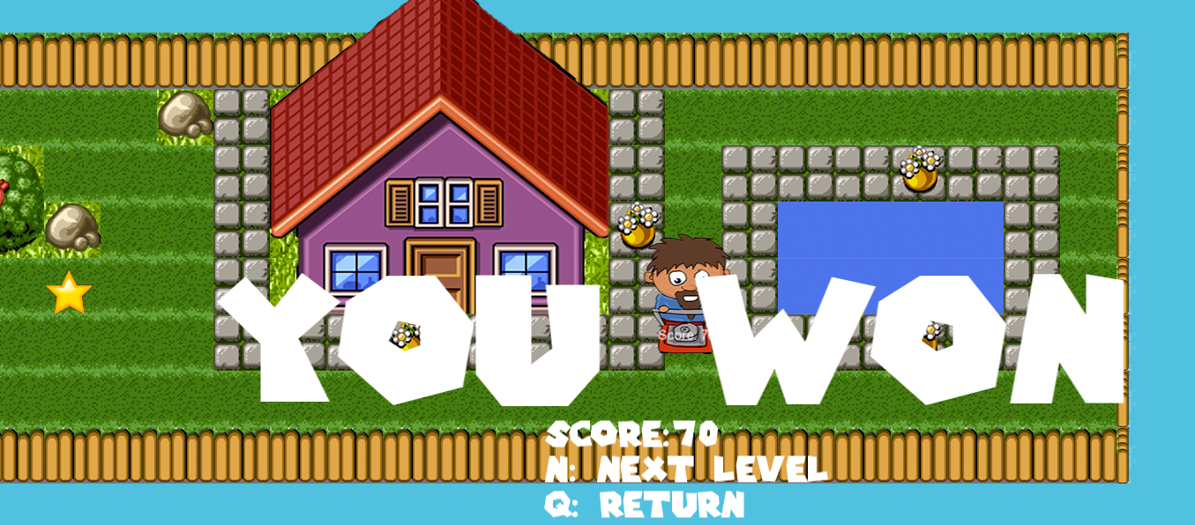

### Screen Descriptions

What is the purpose of each screen?

#### Main Menu Screen

It fulfills the function of presenting the game, giving it a face and options that the player can choose from. The first is to continue with the game and the second is to give configuration options.

#### Options Screen

Allows the player to set their preferences regarding sound and allows them to view the highest scores obtained within the game

## Game Options

The player only can manipulate the background music and sound effects.

## Replaying and Saving

The player can replay the level as many times as desired.

# Section III – Story, Setting and Character

## Story and Narrative

### Back story

It's summer, and the grass in this suburb doesn't stop growing. A young adult, Pablo wants to help his neighbours earn a few extra dollars. For this reason, he decides to mow the grass in his neighbourhood in his spare time.

### Plot Elements

Enemies:

* Dogs
* Porcupines

### Game Progression

Pablo will face different levels. The difficulty will increase as you level up. Each level will be unlocked when the player completes the previous level. On each map, he will find enemies, which will make the task of mowing the lawn more difficult. The player must avoid these opponents and cut all the grass to complete the level.

The player will get a score and, with it, several stars.

### License Considerations

The game is implemented under the Canadian Fair use for educational purposes.

## Characters

### Character #1

#### Back story

Pablo is a young adult that wants to help his neighbours.

#### Personality

Kind, honest and loyal. He is a hard worker but a little coward. He loves nature but hates porcupines.

#### Look

##### Physical characteristics

Pablo has short curly hair. He is tanned by the sun, and he has a long beard. Pablo wears a casual blue shirt with red pants and brown shoes.

##### Animations

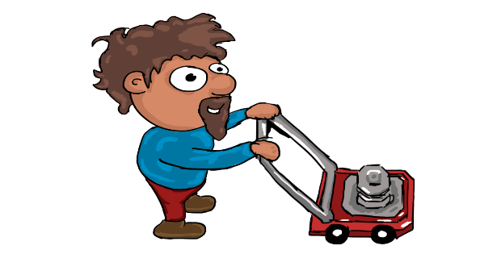

#### Relevance to game story

He is the main character in the game. The game takes place around him. He is in charge of completing the main task of the game.

#### Relationship to other characters

It must be Pablo who avoids the enemies to complete each assigned level.

# Section IV – Levels

## Level #1

### Synopsis

It is the first house that Pablo faces. It is not a very big house. It does not have a huge garden either and has only one enemy.

### Objectives

Mow the grass with the highest possible score.

### Physical Description

There is a small house with a small garden. The garden is taller than it is wide. The house has a small pool and some bushes and rocks

### Map

**Map Sketch**

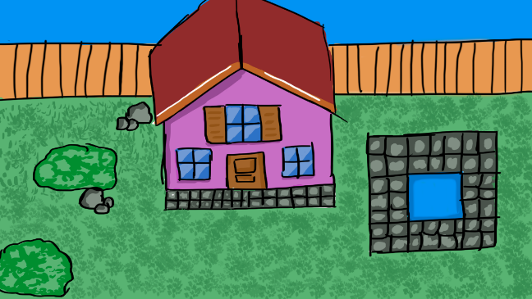

**Real map**



### Critical Path

The game is maze-like, but this does not mean there is only one way to complete the level. There are different ways to do it; it depends on how the player achieves the level since they are free to move the character as desired.

### Encounters

There is only one enemy on this level. The porcupine is lurking in the right area of ​​the map. The player can collide with him in that area.

### Level Walkthrough

The player is free to move through the whole map. The goal is to mow all the grass.

### Closing Material

Level Closing



**Game closing**

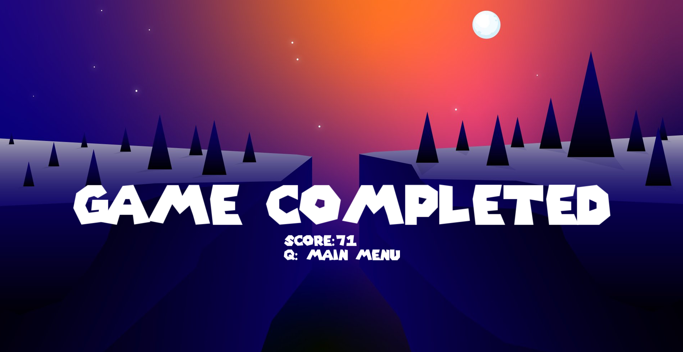

# Section V - Interface

## Visual System

### HUD - What controls

It shows the current player's score as well as the previous best score.

### Menus

There are two menus. The Main Menu presents the video game and the Options Menu. The options menu has a help button, and the user can turn the music and sound effects on and off. At the same time, the player can view the highest scores obtained in the past.

### Rendering System

Videogame engine developed in Game Development class at the New Brunswick Community College. The game is updated in every iteration of the engine.

### Camera

The camera follows the main character.

### Lighting Models

## Control System

The main character will be controlled with the up, down, left and right arrows. Likewise, it can be moved with the keys W (up), A (left), S (down), and D (right). The enter key will be used to select within the menus. The P key will pause the game, and the Q will exit the level.

## Audio

The game will have upbeat music, giving it a summer feeling. It will have background sounds like birds singing, the sounds of the player's footsteps, and the tractor engine. On the other hand, they open sounds when the player collides with the enemies and when the user completes the level.

## Music

The user can control the music from the options menu.

## Sound Effects

The user can control the music from the options menu.

## Help System

The user can learn how to play from the sou options menu.

# Section VI - Artificial Intelligence

## Enemy AI

The enemies (porcupines and dogs) will have a specific area where they will move within the map.

## Friendly Characters

Friendly characters will not move they are just existing at the same point in the whole level

## Support AI

### Player and Collision Detection

The game engine detects in each iteration if the player collides with any of the enemies or objects on the map.

# Section VII – Technical

## Target Hardware and operating system

The device must meet all minimum requirements to open the game:

OS: Windows 8

Architecture: ARM, x86

## Supported game controllers and peripherals

Just PC keyboard.

# Section VIII – Game Art

## Characters

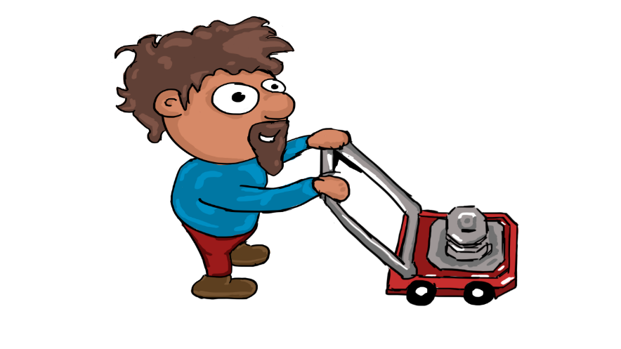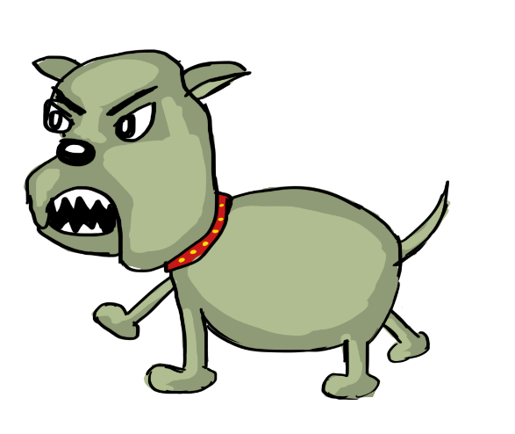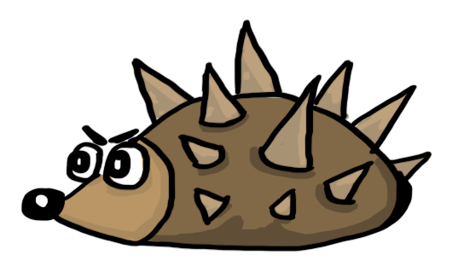

## Environments

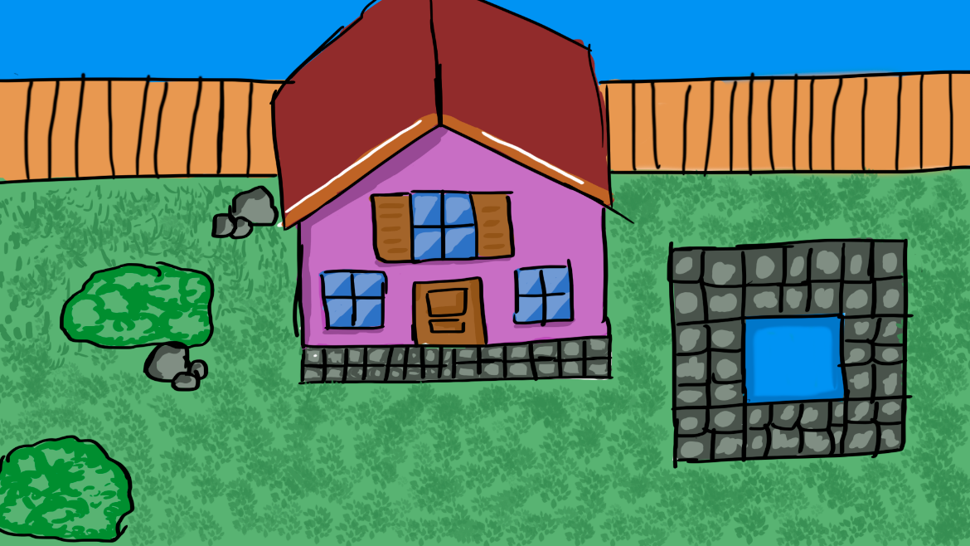

## Menus



